OUR LADY OF FATIMA PARISH, FARRELL, PA.

|  |
| --- |
| Week of June 1, 2025, Calendar of Events  Monday June 2:  Tuesday, June 3: 9:00AM Making of Fatima Cavatelli  In the Good Shepherd Social Hall  Wednesday June 4:6:00PM PRAYER BOOK CLUB  Downstairs in our Social Hall  Thursday, June 5: 9:00AM Making of Fatima Cavatelli  In Good Shepherd Social Hall  ALL DAY ADORATION 6:30AM TO 6:00PM  HOLY HOUR 6:00PM TO 7:00PM-- COME JOIN US  Friday, June 6: 7:00AM FIRST FRIDAY MASS  Saturday, June 7: 4:00 Mass |

|  |  |  |
| --- | --- | --- |
| COLLECTION 05/24/2025 | |  |
| # of Registered Families |  | 395 |
| # of Envelopes Used |  | 86 |
| Good Shepherd Collection |  | $462.00 |
| Offertory Collection |  | $2047.00 |
| Loose Offertory |  | $195.00 |
|  |  |  |

|  |
| --- |
| Altar Candles the week of  JUNE 1 thru JUNE 7,2025  SANCTUARY LIGHT  FRANK & ROSARIA DONATELLI  From AnnMarie Donatelli  SABINA BLACK  From Joe & Janie Gentile & Family  BLESSED MOTHER ALTAR  ANNA & TONY TOMCZAK  From Fran Chervinko  WILLIAM THOMAS  From Beverly & Family  ST. JOSEPH ALTAR  JOE PALANTI  From Rose Settle & Family    *Blessed Virgin Mary Altar Flowers*  *For this week were donated in memory of*  *Frank & Agnes Aiello*  *From The Family* |

|  |  |  |  |  |  |  |  |  |  |  |  |  |  |  |  |  |  |  |  |  |  |  |  |
| --- | --- | --- | --- | --- | --- | --- | --- | --- | --- | --- | --- | --- | --- | --- | --- | --- | --- | --- | --- | --- | --- | --- | --- |
|  | | Intentions | | Requested By | | |  |  | |  | |  | |  | |  | |  | |  | |  | |
| SATURDAY, May 31 at 4:00 pm | | Terry Carter  Joseph Sr. & Sophia Richnavsky | | Rose Settle & Family  Joseph Jr. & Sophie Richnavsky | | |  |  | |  | |  | |  | |  | |  | |  | |  | |
| Monday, June 2at 6:30 am | | Prayer Service | |  | | |  |  | |  | |  | |  | |  | |  | |  | |  | |
| Tuesday, June 3 at 6:30 am | | Prayer Service | |  | | |  |  | |  | |  | |  | |  | |  | |  | |  | |
| Wednesday, June 4 at 6:30 am | | Prayer Service | |  | | |  |  | |  | |  | |  | |  | |  | |  | |  | |
| Thursday, June 5 at 6:30 am | | Prayer Service | |  | | |  |  | |  | |  | |  | |  | |  | |  | |  | |
| FIRST Friday, June 6 at 7:00 am | | Theresa Harkulich | | Blue Army | | |  |  | |  | |  | |  | |  | |  | |  | |  | |
| Saturday, June 7 at 4:00 pm | | Mary Lou Cimoric  Rev. Donald E. Berdis | | Husband, Tom Cimoric  Jim & Heidi Ost & J.J. | | |  |  | |  | |  | |  | |  | |  | |  | |  | |
| MINISTRY  SCHEDULE | | LECTOR | EUCHARISTIC MINISTERS | ALTAR  SERVERS | | GREETERS | |  | |  | |  | |  | |  | |  | |  | |  | |  | |
| SATURDAY 4:00 PM | | Dolly Scugye | Jason Bika  JoAnn Horner | Joe Perrico  J.J. Ost | | John Jarocki  Jean Burke | |  | |  | |  | |  | |  | |  | |  | |  | |  | |
| JUNE 7 |  |  |  | | |  |  | |  | |  | |  | |  | |  | |  | |  | |  | |

“SEVENTH SUNDAY OF EASTER” MAY 31, 2025

*FROM THE PASTORS DESK*

*“Father, they are your gift to me.”*

For over 20 years, Jonathan Clements wrote about personal finance for the Wall Street Journal. Wise and frugal in handling his own finances, Clements was looking forward to a stress-free retirement – but that dream crashed a year ago when he was diagnosed with terminal cancer. His oncologist said he might have a year to live. Jonathan Clements is 61.

He wrote in AARP: The Magazine the cancer diagnosis did not change his spending habits or investing – but transformed his mindset.

“I’m no longer investing for my retirement. Instead I’m investing for my heirs and their time horizon is far longer than mine…One reason I’m not spending like crazy; I want to make sure I bequeath a healthy sum to Elaine (my wife) and my two children, now in their 30s…I also made some financial gifts right away…including large checks to my kids and funding 529 college saving plans for my two grandsons.”

Clements has re-organized his meticulously kept financial records, simplifying everything and keeping only what his family will need. And he’s spent time with Elaine and his sons explaining everything in his estate plan.

But Jonathan Clements has not “checked out” of his life’s work.

“I still want to make a difference in the lives of others. That’s why I continue to write and edit each day. In return, I

end each day feeling fulfilled and with that pleasant sense of progress that makes me happy.

“I refuse to feel angry about my bad luck or despondent over the years I’ll never enjoy. Instead, I’m determined to make the most of each day. I’ve long thought happiness has three ingredients: a sense of financial security: a sense of financial security, time with family and friends, and doing work I love. My diagnosis has made me even more focused on those three things”

(AARP – The Magazine February/March 2025)

In facing his diagnosis with dignity and generosity, Clements has embraced the spirit of Jesus’ prayer in today’s gospel. In the final hours before his death at the Last Supper, Jesus prays for all of us who are his Church today, that “the love with which you have loved me may be in them.” It is that love of God that binds us together as a Church, that makes us not just an association of good people but a family of faith. Such extraordinary love is total, selfless, unconditional and complete: I is love that is centered in our care and concern for another than for our own needs and wants. It is love that is based on the realization that we belong to one another as children of the one God. It is a love that transcends credentials and labels, dears and biases, love that realizes its joy in acts of kindness, compassion and justice. That defines those who are true disciples of Christ.

EARLY TAKE-AWAYS ON LEO XIV

A Catholic journalist in London wrote of his reflections on Pope Leo’s election as he and some others watched the BBC’s coverage…

“I wondered in the moments between the white smoke and the announcement of who the new pope might be whether or not some of the programmatic changes Francis initiated would endure. My fears were allayed when Pope Leo mentioned Francis a couple times and that the Church needed to continue building bridges and keeping our arms open.

“Initially it seemed to me that Francis appeared to draw energy from the crowds while Leo seemed to be a quiet-spoken, a

considered and serious man, a good listener and a balanced leader who might focus on two huge ambitions: peace and church unity. His commitment to the synodal pathway is effectively set in stone.

“As an Augustinian priest, he is a missionary at heart. It is the key impulse in his life and brought him to Peru where he became a bishop and which became his home. Elected by his fellow Augustinians to guide the Order throughout the world for two terms, he was then tapped by Francis to head the body that vets and recommends men to become bishops worldwide.

“A man with wide pastoral (parish/diocesan) experience, he earned a litany of degrees over time and in his early remarks reminded us that ‘God

loves each and every one of us unconditionally.’”

Brendan Hoban, Western People 13.5.2025)

Personally, I don’t believe Leo XIV is a carbon copy of his predecessor, but Francis’ project of reinstating the vision and reforms of the Second Vatican Council, after being on the back burner for about 30 years (1978-2013), seems to be in safe hands. May God grant him a fair wind!

CATHOLIC SERVICES APPEAL 2025 UPDATE.

THANKS TO ALL OF YOU

We are moving right along with

this year’s Appeal.

Our project this year is to update our kitchen in our Basement

Social Hall. We will be starting

the painting of the kitchen in the

second week of June. Once that is complete, we will be ordering our new equipment. We will also be adding a ramp to the right side of the stairs to make it easier to

enter from the Wallis entrance.

*FATIMA CAVATELLI FOR SALE*

Our famous Fatima Cavatelli’s are now for sale not only at our local grocery stores, (Farrell Golden Dawn and Donofrio’s in Hermitage) but they can now be purchased directly from Good Shepherd Church Hall in West Middlesex, every Tuesday and Thursday from 9:00AM to 11:00AM for $15.00 for a 5-pound bag. Let’s support our parish with your purchase!!!!

CAVATELLI

You are now able to purchase Our Famous Cavatelli, here at FATIMA the Church. *BUT ONLY ON SATURDAY’S AFTER 4:00 MASS*. $15.00 for a 5 lb. bag

Marty Andrusky will be downstairs after mass to take your orders.

*Family Perspective*

In today’s gospel, Jesus speaks of unity, not uniformity. Uniformity means everything is the same, while unity requires recognizing and reconciling differences. How do you reconcile differences in your home? Do you listen respectfully, or do you try to manipulate or impose your opinion? The seeds of unity and division are present in every family. What we sow, we reap. What is your family harvest?

*Parenting Pointers*

More on child discipline. Help your child learn to become responsible, If a child leaves their bike out in the yard. It may be rusty or stolen. Don’t always rescue your child. It is better to learn early self-discipline lessons than harder lessons like an untimely pregnancy later in life. Model self-discipline as a parent.

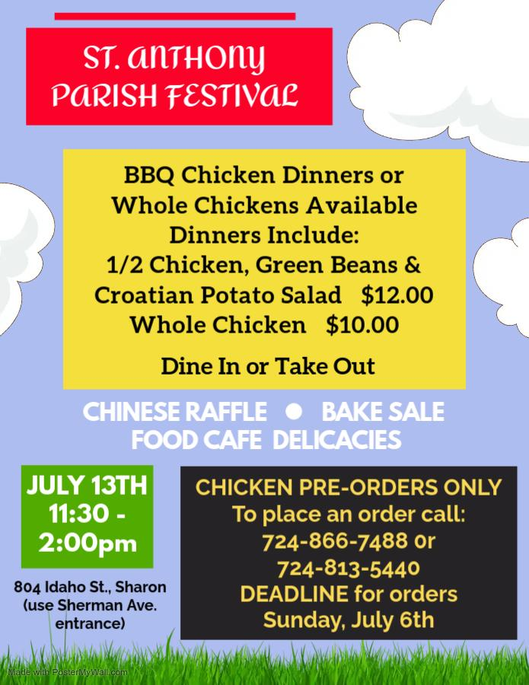

2025 Wedding Anniversary Celebration with Bishop Persico

Diocesan Anniversary Celebrations for couples celebrating 25, 40, 50, 60 or more years of marriage in 2025 will be held at two locations in the Diocese of Erie this summer

Sunday, August 3 at Our Lady of Peace, Erie at 2:00 p.m.

Sunday, August 24 at St. Tobias, Brockway at 3:00 p.m.

Couples and/or Parish staff may complete registration at online  <https://www.eriercd.org/familylifeoffice/anniv.html>, calling their parish office or contact the Mariage and Family Life Office at (814) 824-1210. Registrations are accepted until July 24 for the Erie celebration, until August 14 for the Brockway celebration or until September 11 to be mailed to you.

[Parish Care and Concern Ministry Presentations](https://www.eriercd.org/Parish-Care-and-Concern-Ministry-Presentations-6-1-2025-1.html)   
  
Parish Care and Concern: Are you interested in starting or revitalizing a Parish social ministry? Catholic Charities of the Diocese of Erie invites you to attend an information session to learn more about how Parish Care and Concern can help you use your gifts and talents as a parish family to serve your neighbors in need. On Thursday June 12th at 12pm and again at 5:30 pm, there will be a presentation at Notre Dame Church, 2325 Highland Road, Hermitage. Register at <https://bit.ly/PCandC> or contact Diane Gallagher at [dgallagher@ccincerie.org](mailto:dgallagher@ccincerie.org) or 814-824-1251 for more information. All are welcome.

*Marriage Moment*Just for today, pay attention to your breath, your spirit, your physical wellbeing and be thankful for life no matter how fragile. Ask your spouse to remind you.

*Will there be a wedding in 2025/2026 in your family? This would be a wonderful way to start that journey. If you have any questions, please call the Parish office 724-346-3359*

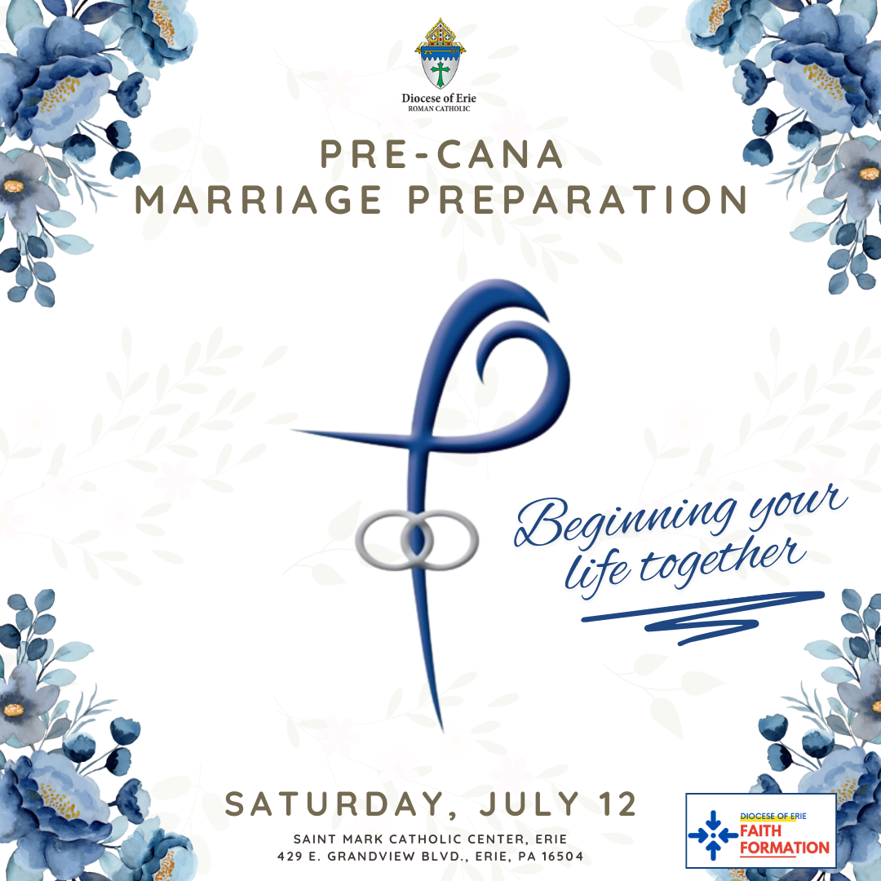

*COME AND JOIN US*



*HERE AT FATIMA*

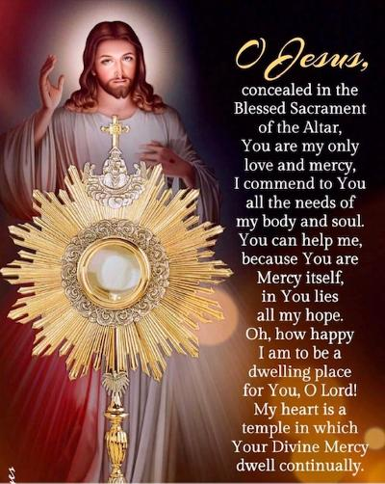

ALL DAY ADORATION EVERY THURSDAY FROM 7:00am TIL 7:00pm