OUR LADY OF FATIMA PARISH, FARRELL, PA.

|  |
| --- |
| Week of June 22, 2025, Calendar of Events  Monday June 23:  Tuesday, June 24: 9:00AM Making of Fatima Cavatelli  In the Good Shepherd Social Hall  Wednesday June 25:6:00PM PRAYER BOOK CLUB  Downstairs in our Social Hall  Thursday, June 26: 9:00AM Making of Fatima Cavatelli  In Good Shepherd Social Hall  ALL DAY ADORATION 6:30AM TO 6:00PM  HOLY HOUR 6:00PM TO 7:00PM-- COME JOIN US  Friday, June 27:  Saturday, June 28: 4:00PM MASS |

|  |  |  |
| --- | --- | --- |
| COLLECTION 06/072025 | |  |
| # of Registered Families |  | 393 |
| # of Envelopes Used |  | 100 |
| Attendance |  | 165 |
| Offertory Collection |  | $1937.00 |
| Loose Offertory |  | $141.00 |
|  |  |  |

|  |
| --- |
| Altar Candles the week of  JUNE 22 thru JUNE 28,2025  SANCTUARY LIGHT  MARGARET PACELLO  From Sam Petrillo Family  MARY CONTI  From Sandy & Karen Rosati  BLESSED MOTHER ALTAR  HAPPY BIRTHDAY GRANDMA  From Darlene Bartholomew  ST. JOSEPH ALTAR  DEACON RONALD ADKINS  From Anne M. White    *Blessed Virgin Mary Altar Flowers*  *For this week were donated in memory of*  *JOANN & RAY GIARDINA*  *From AnnMarie Fry (Consiglio)* |

|  |  |  |  |  |  |  |  |  |  |  |  |  |  |  |  |  |  |  |  |  |  |  |  |
| --- | --- | --- | --- | --- | --- | --- | --- | --- | --- | --- | --- | --- | --- | --- | --- | --- | --- | --- | --- | --- | --- | --- | --- |
|  | | Intentions | | Requested By | | |  |  | |  | |  | |  | |  | |  | |  | |  | |
| SATURDAY, JUNE 21 at 4:00 pm | | Patricia Barkovich  James Falconi | | Randy & Roberta  Napolitan Family | | |  |  | |  | |  | |  | |  | |  | |  | |  | |
| Monday, June 23 at 6:30 am | | Prayer Service | |  | | |  |  | |  | |  | |  | |  | |  | |  | |  | |
| Tuesday, June 24 at 6:30 am | | Prayer Service | |  | | |  |  | |  | |  | |  | |  | |  | |  | |  | |
| Wednesday, June 25 at 6:30 am | | Prayer Service | |  | | |  |  | |  | |  | |  | |  | |  | |  | |  | |
| Thursday, June 26 at 6:30 am | | Prayer Service | |  | | |  |  | |  | |  | |  | |  | |  | |  | |  | |
| Friday, June 27 at 6:30 am | | Prayer Service | |  | | |  |  | |  | |  | |  | |  | |  | |  | |  | |
| Saturday, June 28 at 4:00 pm | | Nicola & Anna Galardo  Theresa Harkulich | | Son, Nick  Fatima Altar and Rosary Society | | |  |  | |  | |  | |  | |  | |  | |  | |  | |
| MINISTRY  SCHEDULE | | LECTOR | EUCHARISTIC MINISTERS | ALTAR  SERVERS | | GREETERS | |  | |  | |  | |  | |  | |  | |  | |  | |  | |
| SATURDAY 4:00 PM | | Christopher Connelly | Marsha Petrillo  Larry Masotti | Anthony Elisco  J.J. Ost | | John Jarocki  Jean Burke | |  | |  | |  | |  | |  | |  | |  | |  | |  | |
| JUNE 28 |  |  |  | | |  |  | |  | |  | |  | |  | |  | |  | |  | |  | |

“CORPUS CHRISTI” JUNE 22, 2025

*FROM THE PASTORS DESK*

*Those who eat my flesh and drink my blood will have my life in them.”*

Mealtime is just about the best time for everybody. Some may prefer bar-be-que to Italian, vegan to omnivore, dessert to the entrée or large portions to petite, but just about everybody I know considers “time to eat” among the happiest words they hear all day. And why not? Food is not just the fuel that keeps us running – it is a pleasure. And mealtime at its best is a social event when we come together with friends and share our lives.

That’s probably why food is at the heart of most of our celebrations. Just recently Fathers’ and Mothers’ Days, Easter, New Year’s, Christmas and Turkey Day have weighed down our dining room tables. We plan special days around the food that customarily accompanies it. I suppose we plan every day around food, whether it’s a to-go bag or gliding through the drive-thru.

As Catholic Christians it’s the Eucharist around which we navigate our weekends; our liturgical feasts, saint’s days, holy days and ordinary days are centered around a meal of bread and wine. Kinda makes sense, doesn’t it, that the sacramental action that accompanies our lives as Christians is a meal. It would be odd if it weren’t.

The bread and wine of our Eucharist may look pretty simple, possibly inadequate, to anyone who was looking for something filling. And if we took a serious gander around our communion table we’d realize that it’s set among people who may be strangers to each other. Compared to the family gatherings, the meal we gather to share in the community of faith may seem to be a rather sterile event, a sparse ritual in the worst sense of the word. But remember Jesus took a couple slippery fish and some hard bread and satisfied thousands of people with it.

What we learn slowly over time is that satisfaction doesn’t come simply from the food but from the blessing that the meal imparts. It might come from the occasion that brought us all together, or the eyes of the one who looks across the table at you with love. It may be the hands that serve you when yours are no longer steady, or in the one who picked up the tab so that you could enjoy a feast that you couldn’t afford yourself. In the case of our Eucharist, all of these blessings are present and true. Loaves and fishes, bread and wine, a roomful of strangers, and the love of Jesus Christ. It is enough!

Of all the memorable meals we’ve all enjoyed, this one recalls for us the greatest hour of human history, when God’s life and our lives were joined in one eternal reality. What’s more, our Eucharist isn’t simply a reenactment but an actual participation in that holy hour. What once was, is now – and will be forever. Scientists tell us that when we remember something, our brains recreate the chemistry of he original

event so that we actually “relive” the

experience in our bodies as well as in our thoughts. What happens in the action of our Eucharist is more powerful still. By God’s design, our sacrament makes real and vital the presence and life of Christ in our midst. Christ’s own journey from death into everlasting life becomes ours.

The human race once stood before a locked door through which we could not pass. Our participation in this meal identifies us as the people with the key, and freedom of passage. If we understood what this holy meal represents, we should treat it like all the feasts and rush to claim our place at table. We would dance up the aisles; dance our way out of the church as well, brimming with the life that has no end.

Our world could be a lonely place, but for parishes centered on the Eucharist. Jesus was unwilling to send people off to find their own provisions; he fed them in groups of 50, keeping the community together. Yet so often, Holy Communion becomes “holy Isolation” as each one enters into some personal, solitary frame of mind to get “his” or “her” sacrament. A few moments of silence or reflective music is welcome in our noisy world, but the Eucharist is never a personal covenant between me and God.

When we eat this bread and drink this cup, the consequences are always a shared and common life.

Blessed Corpus Christi to you all!

Fr. Frank and Fr. Glenn

*FATIMA CAVATELLI*

Our famous Fatima Cavatelli’s are now for sale not only at our local grocery stores (Farrell Golden Dawn and Donofrio’s in Hermitage) but they can now be purchased directly from Good Shepherd Church Hall in West Middlesex, every Tuesday and Thursday from 9:00AM to 11:00 for $15.00 for a 5*pound bag.

*Let’s support OUR parish with your purchase!!!!*

CAVATELLI can also be purchased here at the FATIMA after Saturday 4:00PM mass. Please see Marty or Deb Andrusky after mass to place and pick up your order!!!!!

*Family Perspective*

In today’s gospel Jesus teaches that we will find abundance by sharing what little we have. Regardless of how limited our time, money, or food may be, it becomes sufficient when shared.

*Parenting Pointers*

Officially summer begins on the Summer Solstice, June 20 – the longest day of light each year. Try doing some special fun activity with you child this “long day.” Stay up late, play outside, wait for older children to return home. Celebrate!

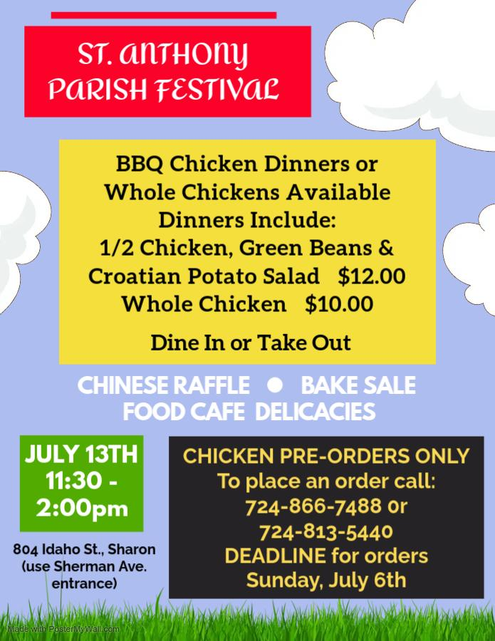

*COME AND JOIN US*



*HERE AT FATIMA*

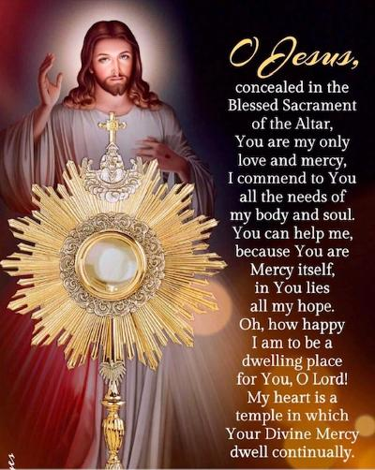

ALL DAY ADORATION EVERY THURSDAY FROM 7:00am TIL 7:00pm



*Why do we do that?*

*Catholic Life Explained*

*Question:*

*Why do Catholics Genuflect?*

*Answer:* Genuflection is an act of devotion that literally means, “to bend the knee.” For many Catholics, it’s an almost automatic gesture that we perform before entering our pew or row of seats at Mass. But, like many of the symbols, and gestures of our faith tradition, genuflecting can also be an invitation for deeper reflection.

The practice of “bending the knee,” is an ancient way of recognizing the presence someone greater than we are. It has been said that the practice dates back to the time of Alexander the Great, but it became a common part of etiquette in the royal courts of the Middle Ages. From throne rooms and palaces, it was a small step to

genuflecting, becoming part of the

devotional lives of Christians, who used this secular gesture as a way of recognizing the presence of the One who is King of Kings, especially in

the Eucharist.

Today Catholics are asked to genuflect in the presence of the Blessed Sacrament (whether in the .tabernacle of exposed on the altar during

eucharistic adoration). So, while it

has become second nature to genuflect before entering your seat in church, we should pay attention to where the Blessed Sacrament is kept in each church or chapel that we visit and genuflect in the direction of the tabernacle here the Blessed Sacrament is kept. In churches or chapels in which the tabernacle is in the separate space, we are invited to simply bow toward the altar. In addition to genuflecting before the Blessed Sacrament, we are also instructed to genuflect before the cross used for veneration on Good Friday (during

the solemn celebrations of the Lord’s Passion) and any time a relic or the True Cross is displayed for veneration. This long-standing tradition is a way to honoring the cross as the great sign of our salvation and of showing devotion to the passion of Jesus.